C++ ASSIGNMENT LOOPS 1

Q1.

#include<iostream>

using namespace std;

int main() {

for (int i=1;i<=100;i+=2)

{

cout<<i<<" ";

}

}



Q2.

#include <iostream>

using namespace std;

int main()

{

    for (int i = 1; i <= 100; i += 2)

    {

        if (i % 3 == 0)

        {

            cout << i << " ";

        }

    }

}

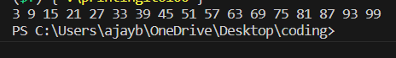

Q3.

#include <iostream>

using namespace std;

int main() {

int n;

cout<<"Enter the numbers: ";

cin >> n;

for (int i = 1; i <= 10; i++) {

cout <<n<<"\*"<<i<<" = "<<n\*i<<endl;

}

}

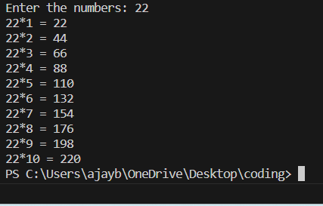

Q4.

#include <iostream>

using namespace std;

int main() {

int n;

cout<<"Enter the numbers: ";

cin >> n;

for (int i=4;i<=(3\*n+1);i=i+3){

     cout<<i<<" ";

}

}

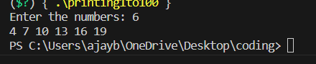

Q5.

#include <iostream>

using namespace std;

int main() {

int n;

cout<<"Enter the numbers: ";

cin >> n;

int a=3;

for (int i=1;i<=n;i++){

     cout<<a<<" ";

     a=a\*4;

}

}

